Understanding Youth Rights
Legal Information for Community Workers
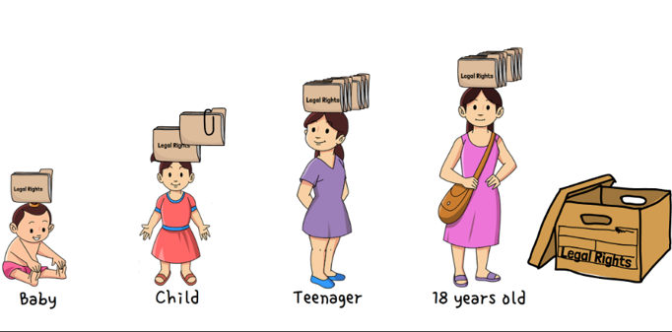


In your work, do you wonder about the rights of children and youth?
This free workshop is for you!
You will:
- Understand the concept of children and youth as independent rights holders
- Learn about various age-based laws and legal rights
- Apply a Youth Rights Framework to fact scenarios
- Reflect on your assumptions about youth rights
- Learn about Justice for Children and Youth, a specialized community legal clinic
DATE and TIME: add date and time
PLACE: add venue (online or physical)
REGISTER: add registration details

