Understanding Youth Rights
Legal Information for Community Workers
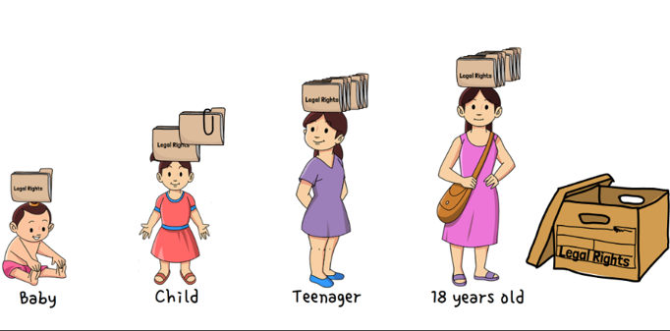


AGENDA (sample)

- Welcome and Introductory Activity | 9:00–9:40
- Video and discussion of Youth Rights Framework | 9:40–9:55
BREAK (10 minutes)
- Youth rights scenarios | Q & A | 10:05–10:40
- Self-reflection questions | 10:40–10:45
- What can community workers do? | Useful Resources | 10:45–10:55
- Wrap-up, Feedback, and Evaluation | 10:55–11:00

